Fast-Forward Merge

What is Fast-Forward Merge in Version Control?
# Source: AI Source: Provided by: [Data Path: Persons Table -> ID Column: 1, Name_En Column: Motasem Essam] -> From: [ChatGPT] on [2/15/2026]
A fast-forward merge happens when the branch you’re merging has all the commits ahead of your current branch, and there are no divergent changes.
In this case, Git doesn’t need to create a new merge commit — it simply moves the branch pointer forward.

How it works
# Source: AI Source: Provided by: [Data Path: Persons Table -> ID Column: 1, Name_En Column: Motasem Essam] -> From: [ChatGPT] on [2/15/2026]
- Suppose your history looks like this:
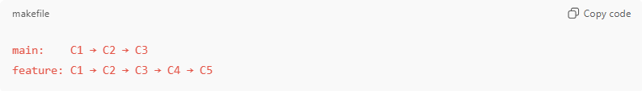
main: C1 → C2 → C3
feature: C1 → C2 → C3 → C4 → C5
- main has no new commits since the branch split.
- feature has two new commits: C4, C5
- Merge feature into main:
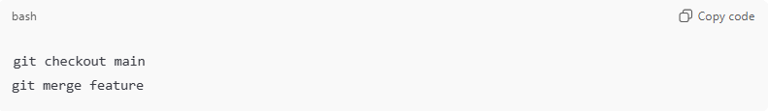
git checkout main
git merge feature
- Git sees that main is behind feature and can just move main to point to C5.
- No merge commit is created
Result:
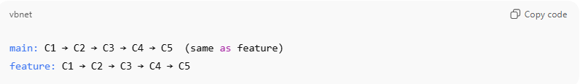
main: C1 → C2 → C3 → C4 → C5 (same as feature)
feature: C1 → C2 → C3 → C4 → C5

Key Points
# Source: AI Source: Provided by: [Data Path: Persons Table -> ID Column: 1, Name_En Column: Motasem Essam] -> From: [ChatGPT] on [2/15/2026]
- Only works if the current branch has no new commits since the split
- No merge commit — history remains linear
- Simple and clean for small feature updates

Fast-Forward vs Three-Way Merge
# Source: AI Source: Provided by: [Data Path: Persons Table -> ID Column: 1, Name_En Column: Motasem Essam] -> From: [ChatGPT] on [2/15/2026]
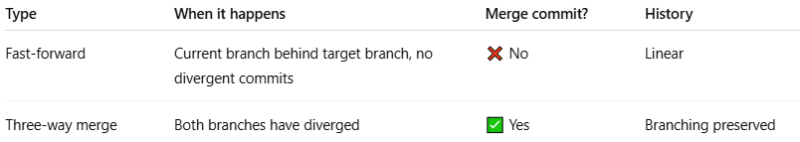
Type | When it happens | Merge commit? | History
Fast-forward | Current branch behind target branch, no divergent commits | ❌ No | Linear
Three-way merge | Both branches have diverged | ✅ Yes | Branching preserved

Analogy
# Source: AI Source: Provided by: [Data Path: Persons Table -> ID Column: 1, Name_En Column: Motasem Essam] -> From: [ChatGPT] on [2/15/2026]
- Branches = two roads
- If your road hasn’t gone anywhere new, Git can simply follow the other road (fast-forward).
- If your road went somewhere different, you need a bridge to combine them (three-way merge).

💡 Memory trick:
# Source: AI Source: Provided by: [Data Path: Persons Table -> ID Column: 1, Name_En Column: Motasem Essam] -> From: [ChatGPT] on [2/15/2026]
Fast-forward merge = just move the pointer forward → no extra commit needed ✅

